Get a quote for your engine or gearbox

Form comes out to fill relevant details

What are remanufactured and rebuilt engines?

If the engine in your vehicle is no longer performing to your expectations or has completely broken down, there’s no need to trade for a new or newer used vehicle. After all, you didn’t intend to replace your vehicle before the engine got tired, why would you now?

Replacing your engine with a MOTONGEN stock replacement engine will cost considerably less than replacing the vehicle. We offer 1-year guarantee.

1-year service remote assist.

We have the option of selling with recommended engine oil and oil filter because the wrong lubricant can cause damage to the engine.

MOTONGEN’s Engine Process

1 YEAR/10,000 KILOMETERS WARRANTY

MOTONGEN can offer this beefy warranty on our remanufactured gas engines because every one of them goes through our extensive "Do It Right" process that ensures worry-free operation. Our optional Premium Service Plan provides allowances for such items as towing, car rental, fluids and premium labour should a problem arise.

THOROUGH CLEANING

Every MOTONGEN reman petrol engine is partially or completely disassembled. Blocks, heads, connecting rods, crankshafts and camshafts are thoroughly cleaned through a variety of processes to remove contaminants that can result in premature wear to internal engine components and early engine failure.

CRANKSHAFTS

Crankshafts are precision machined to exact tolerances with no odd size bearings. Thrust surfaces (domestic engines) are micro-polished to provide precise surface finishes for smooth engine operation and reduced thrust bearing wear. Every journal is inspected and measured with critical accuracy. After machining, oil holes are chamfered to improve lubrication and every journal polished to a smooth finish for long bearing life. Crankshafts are thoroughly cleaned with special emphasis to flushing and brushing out oil passages to remove any contaminants.

CAMSHAFTS

Remanufactured Engines FAQs

**What is the difference between a used engine, a rebuilt engine and a remanufactured engine?**

**USED ENGINES**

Used engines are taken directly from a vehicle typically a junkyard vehicle. There are no provisions for disassembly, internal cleaning, or inspection with a used component. Many used or junkyard components may have high mileage and a poor maintenance history – a failure waiting to happen. Many used or junkyard components come from a vehicle that was involved in an accident and may have unseen damage.

**REBUILT ENGINES**

To rebuild is to recondition by cleaning, inspecting and replacing severely worn or broken parts. Serviceable parts are reused within the manufacturer’s acceptable wear limits. The quality of rebuilt components vary widely and many come with only a short-term warranty.

**REMANUFACTURED ENGINES**

To remanufacture is to make as closely to new as possible. All core material – head and block castings, crankshaft, camshaft and rods - are carefully inspected, checked against original equipment measured specifications for correct dimensional tolerances and precisely machined. Replacement parts are new or requalified to meet exacting standards and tolerances.

Do you need an engine? More information on the options available to you

In general, there are four types of engines you will come across during your search – remanufactured engines, rebuilt engines, used engines, and new engines.

* Remanufactured engines are engines that are rebuilt to the exact specifications of the original. When remanufacturing an engine, a builder will repair some parts, reuse others, and add new parts where needed. Remanufactured engines are tested to original equipment standards.
* Junkyard engine. Most People rely on your Mechanic to buy the engine and face the risk of getting a locally used or poorly overhauled engine with 2 weeks guarantee. Most cases end up at the police station.
* Rebuilt engines on the other hand are only fixed enough to solve the issue that caused it to fail in the first place. Damaged parts are disassembled and worn components are replaced to bring the engine back up to a working standard. Unlike remanufactured

HOW THE ENGINE IS DELIVERED

We sell the engine without sensors or actuators. On request, we sell your engines with spark plugs and ignition coils. We sell with Oil filters. We can provide Installers in different locations.

MOTONGEN offers to buy your old engine/ gearbox from you or give you a discount on the engine you are buying. Yes, like an exchange. Your old engine is called a core.

GEAR BOXES

A major cause of transmission failure is contamination. Would you believe a particle as small as a hair can lead to transmission failure? It can. A human hair is only 30-35 microns in diameter, while the smallest particles most transmission filters will remove are 60 microns in diameter. Small contaminants, not removed by the filter, remain suspended in the fluid until they eventually find their way to the internal components of the transmission. If transmission failure does occur, a significant amount of contaminant will collect in the cooler.

GEAR BOXES

**1 YEAR/10,000 KILOMETRES WARRANTY**

MOTONGEN can offer this beefy warranty on our remanufactured automatic and manual transmissions because every one of them goes through our "Do It Right" process that ensures worry-free operation. Our optional Premium Service Plan provides allowances for items such as towing, car rental, fluids and premium labour should a problem arise.

**THOROUGH CLEANING**

Every MOTONGEN reman engine and transmission is thoroughly disassembled then cleaned to remove contaminants that result in premature wear to gears, bearings, shafts and other precision components like the valve body.

Transmission cleaning includes individual component hand washing. Parts are carefully inspected and bushing surfaces are polished to a micro-finish for extended bushing life.

**EXACT TOLERANCES**

As transmission technology advances, the need to maintain tolerances becomes increasingly important. MOTONGEN’s thorough inspection and precise machining processes are critical to ensure proper operating pressures and provide for a long service life from your MOTONGEN Remanufactured Transmission. Examples of MOTOMI’s machining processes include:

* Case and valve body resurfacing along with profilometer inspection of shaft finish that enable JASPER to maintain exact standards and precise tolerances in all phases of transmission remanufacturing.
* The oil pump and gears are carefully measured to make sure they are within the exact tolerance range, if this is not met they will be machined.

HOW THE GEARBOX COMES

Our gearboxes are sold with the appropriate transmission oil needed because a bad transmission oil will damage the transmission in a matter of weeks.

Old core gearboxes can be sent to MOTONGEN for a discount.

Installation kits

MOTONGEN provides custom packaged parts kits to complete the installation of your MOTONGEN remanufactured engine.

These engine installation kits come with brand new parts from quality manufacturers and will arrive at your installer's workshop with your MOTONGEN remanufactured engine and ready to install

MOTONGEN Academy

### Training Program.

1 year accelerated / 2 years program. It is an intense program. Learn all you need to know about engine overhaul and precision testing.

Terms and Conditions apply

About Us

MOTONGEN is an engine, gearbox and axles remanufacturing company, today we are building the nation's largest collection of remanufactured of petrol, transmissions, differentials, rear axle assemblies, performance engines, and electric motors. We procure engines for our customers across the nation and West Africa coast.

**Our Culture.**

The basis of our corporate philosophy can be found in these words: "Do It Right...have fun.

**Mission**

To help vehicle owners and workshops reduce mechanical waste and save them the financial burden of returning bad engines and buying engines that will not last.

At MOTONGEN we expect everyone who joins our company to work hard and maintain our commitment to safety, quality, productivity, customer service, the reduction of waste and contributing to our efforts of being environmentally friendly

**Vision**

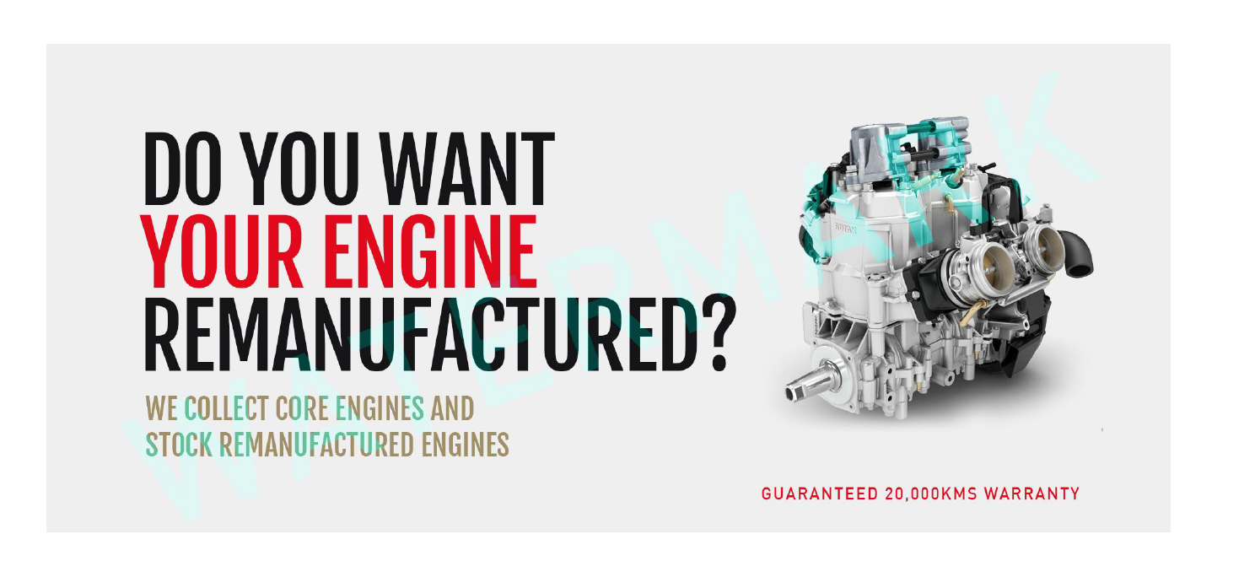

# **Installer and Fleet Resources**

# Across the country, and major cities in West Africa, we have partnered with quality technicians, auto repair workshops and fleets have aligned themselves with MOTOMI to instil confidence in their customers or vehicles used in the fleet.

# We will ship to any location of choice.

**GEAR COOLER**

##### A major cause of transmission failure is contamination. Would you believe if we told you that a particle as thin as a hair can lead to gear failure? It can. A human hair is only 30-35 microns in diameter, while the smallest particles most gear filters will remove are 60 microns in diameter. Small contaminants, not removed by the filter, remain suspended in the fluid until they eventually find their way to the internal components of the gear.

Terms and Conditions apply

ABOUT US

###### MOTONGEN is an engine and gearbox remanufacturing and procurement company. We help our various customers across West Africa provide engines, gearboxes and axles to their fleet of cars and light-weight trucks to get them back on the road. We operate an international standard engine lab that test, cleans, inspects, optimize the engines and gearbox we sell to our customers. Our technicians do live-run of engines, meter-assisted dynamometer testing, cylinder pressure test. Our engine OEM specifications, correcting problems in original design. We are the only engine seller that can offers you a 1-year guarantee.

Assembled by skilled technicians continuously trained in the latest technology of engine overhaul and rebuild.

**Our Culture.**

The basis of our corporate philosophy can be found in these words: "Do It Right. Once and for all.”

**Mission**

To help vehicle owners, fleet owners save money and layoff time of there vehicles, to reduce mechanical waste and save them the financial burden of returning bad engines and buying engines that will not last.

At MOTONGEN we expect everyone who joins our company to work hard and maintain our commitment to safety, quality, productivity, customer service, the reduction of waste and contributing to our efforts of being environmentally friendly

Axle and Differentials

Four Wheel Drive/ All-Wheel Drive or 2 Wheel drive

###### MOTONGEN offers a complete line of front differentials for four-wheel drive and all-wheel drive applications.

* Bearings are preloaded to OEM standard which provides for longer bearing life along with the unit’s smooth operation and its proper break-in.
* Differentials are inspected for correct backlash clearance. This inspection is performed to ensure proper gear lubrication for reduced noise and to avoid overheating, especially important in severe-duty applications.
* Tooth contact pattern is inspected and adjusted to utilize the full structure of the gear. This procedure ensures minimum gear noise and reduced gear fatigue.

MOTONGEN Engines & Transmissions also offers 4WD and AWD actuator assemblies if given the part number.

Facts about Axle

#### Most 4X4s have never had their oils changed.

#### Most differentials are built tough and mostly forgotten to be serviced.

#### A 4X4 or 4matic or Quattro, all mean the same thing, usually has a front and back axle and a transfer case right along the middle of the car -all connected by the propeller shaft.

#### Most mechanic workshops either don't remember to advice the client about an axle service.

#### We are here to supply.

* SUVs and Auto workshops have to service the front and rear differential in the SUV
* Remanufacturing is to make as closely to new as possible.
* Components are carefully inspected, checked against original equipment, measured with specifications for correct dimensional tolerances and precisely rebuilt and remanufactured.
* Replacement parts are new or Used parts that re-qualified to meet exact standards and tolerances.

Find An Installer

Thank you for your interest in MOTONGEN Engine and Gearbox Remanufactured Products

If you already work with an automotive professional, they will be happy to discuss the installation of our products. If you need an installer, MOTONGEN is affiliated with many professional mechanics, workshops and automotive repair facilities throughout the country and across West Africa, and we may help you find one in your area. Indicate by filling the form or chatting with us here.

Before you know it, you'll be driving away in your vehicle with the satisfaction of knowing you made a sound, economical decision that will allow you to continue to enjoy your present car, truck, van or SUV for years to come.

MOTONGEN will not be liable for damage done if engine is installed incorrectly or poorly or the appropriate lubricants were not used.

FAQS ABOUT MOTONGEN

**What is the warranty on a MOTONGEN remanufactured engine?**

Most applications for MOTONGEN engines/ gearbox/ axles are covered by a 1 Year/10,000 kilometres (whichever occurs first) nationwide warranty. Terms and conditions apply. A full warranty disclosure is available on this website. We sell the recommended oil with our components to give it the best chances of longevity.

**How can I find a price for one of your reman engines?**

MOTONGEN offers several options for you to obtain pricing on our remanufactured engines. We encourage you to speak with the automotive technician that services your vehicle for better pricing. If you do not have a facility that you work with on a regular basis, you can make a request.

**Where can I purchase your engines?**

If you are an installation facility, fleet or a commercial user, you can contact our Sales Department at +2348033603906. Vehicle owners can purchase MOTONGEN remanufactured engines from the automotive service facility that you frequent. If you don’t have a facility that you trust, you can find a MOTOMI installer near you with our Installer Locator.

**Where can I find an installer?**

We can set you up with an installer. Simply fill the form here.

**Do you offer a reman engine for my vehicle?**

Chances are very good that we have a remanufactured engine for your Vehicle, if we do not, we will procure one for you anywhere in the world. MOTONGEN remanufactures practically any domestic gas engine for cars, trucks, vans and SUVs, as well as for a number of foreign applications.

**How soon can I get an engine for my vehicle?**

OUR STORY

**Why MOTONGEN?**

We have operated 2 Auto workshops in Lagos for the past 9 years and have dealt with many engine and gearbox suppliers. Traders usually sell engines and gearboxes with only 1- or 2-weeks guarantee. This usually leads to problems when the engine or gearbox starts to fail.. This has caused many conflicts that end up unresolved in the police station.

How do you explain to your customer that for an engine of 700,000, there is only 2 weeks guarantee?

The problem might be that a bad equipment or a bad oil or filter was used for the gearbox/engine, which ended up damaging the engine. This is why we choose to sell our engines with the required engine oil and filter.

All workshops face this problem and it gets multiplied when the workshop or car is not resident in Lagos. When we started shipping engines that are verified and remanufactured, we were able to sell with a 1 year guarantee and deliver the engine.

We have technical partners and the right equipment to guarantee your engine or gearbox.

Enough is enough, fleet managers, end users, mechanic workshops, put your mind at rest.

Call to order here. Fill form here